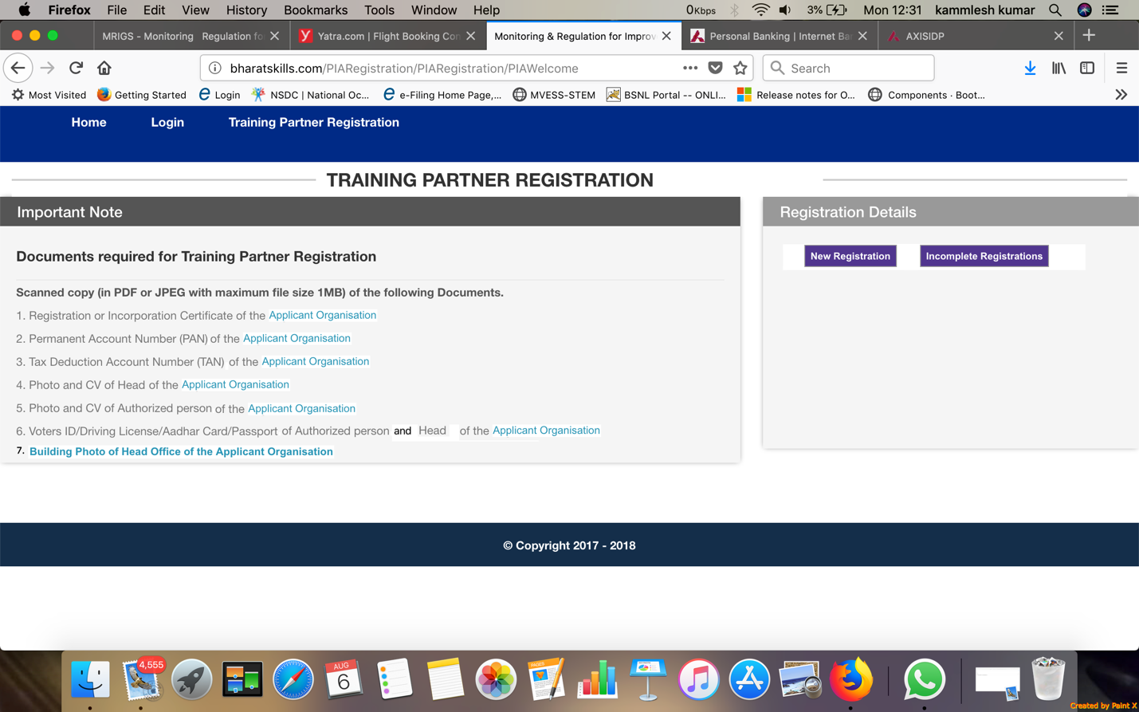

<Display Name of the Organization> <Display Training Partner Code>

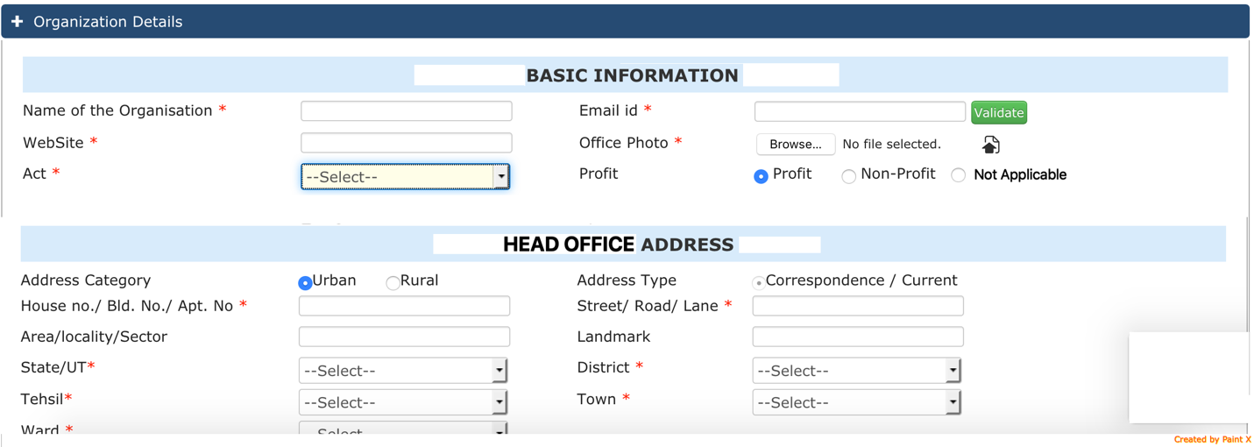

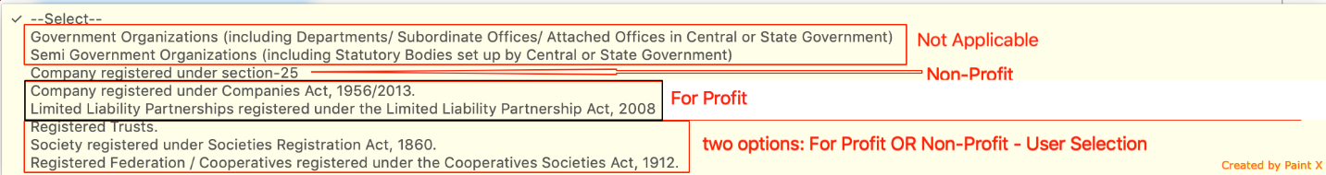

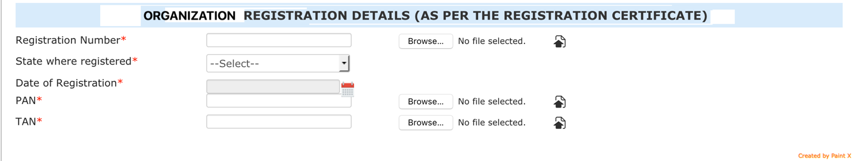

<Save & Continue> <close>

<SEPARATE SECTIONS (like Organization Details)>

**AUTHORIZED SIGNATORY**

Name of the Authorized Signatory

Designation

Email id

Mobile Number

Address (as given in organization address)

PAN* <user input> <upload document>

Voter Id/ Passport/ Driving Licence (Select one option from drop-down)* <user input> <valid till date in case of Passport/ Driving Licence else not required> <Upload document>

Upload CV of the Aurhorized person (self Authenticated): <upload>

Upload the scan of the original Authorization document to act as Authorized Signatory for the Registration: <upload>

**HEAD OF THE ORGANIZATION**

Is The Authorized Signatory also the Head of the Organization? Yes/ No

If Yes, replicate the above data and fields

If no, the data will be entered by the user

Name of the Head of the Organization

Designation

Email id

Mobile Number

Address (as given in organization address)

PAN* <user input> <upload document>

Voter Id/ Passport/ Driving Licence (Select one option from drop-down)* <user input> <valid till date in case of Passport/ Driving Licence else not required> <Upload document>

Upload CV of the Aurhorized person (self Authenticated): <upload>

<Save & Continue> <close>

DECLARATION Cum UNDERTAKING

1. DECLARATION

|  |  |  |  |
| --- | --- | --- | --- |
| A | Has the registering organization that intends to submit proposal under Terms of Reference of the RFP or its owners/Directors ever been convicted by a court for any criminal offence or any other offence involving moral turpitude or fraud or have been found guilty of any economic offence at any time in the past?.* | <Yes/ No> | <if Yes, Remarks are mandatory> |
| B | Has the registering organization that intends to submit proposal under Terms of Reference of the RFP been associated with an organization or its owners/directors been an employee or director of an organization or over which applicant organization or its owners/directors exercised management or policy control, or ever been convicted of any criminal offence or any criminal suit filed during the period of association?.* | <Yes/ No> |  |
| C | Has the registering organization that intends to submit proposal under Terms of Reference of the RFP or its owners/directors ever been found guilty by any court / regulatory body / self-regulatory organization / stock exchange for any offence in India or abroad?.* | <Yes/ No> |  |
| D | Has action ever been taken/initiated against the registering organization that intends to submit proposal under Terms of Reference of the RFP or its owners/directors by the Ministry of Skills Development and Entrepreneurship (MSDE) or Any Ministry or NSDC for suspension or cancellation or debarring or blacklisting, or any show cause notice issued for acts committed during undertaking of implementation of any projects in the past?.* | <Yes/ No> |  |
| E | Has the registering organization that intends to submit proposal under Terms of Reference of the RFP or its owners/Directors ever been associated with any organization as a director or an employee of such organization against which the Ministry of Skills Development and Entrepreneurship (MSDE) or Any Ministry or NSDC had initiated action/taken action of suspension or cancellation or debarring or blacklisting, or any show cause notice issued for acts committed during the period of association?.* | <Yes/ No> |  |

1. UNDERTAKING

|  |  |
| --- | --- |
| page1image36069504 | I have read the RFP and understand the provisions laid out therein and understand that the only registration as a Training Partner does not entitle my organization for allotment of training target as a right.* |
| page1image36069504 | I am aware that fee paid by me towards registration as a training partner is not refundable and I, on behalf of the organization or my successors, shall not claim any refund of the fee paid by the organization for any reason whatsoever. * |
| page1image36117408 | I have uploaded all valid documents and no fake documents has been uploaded in this registration form.* |
| page1image36117408 | I certify that the information provided by me with respect to the organization, authorized signatory and head of the organization will form part of the organization evaluation process and due-diligence in the event of my application for allocation of the target under the terms of reference of the RFP and will not be changed after submission of the registration form.* |
| page1image36123440 | I certify that I am the authorized person to file the training partner registration on behalf of the applicant organization, and also certify that the information furnished in this application and all the corresponding documentary proof provided is complete and correct in all respects to the best of my knowledge. In case any information provided in this application is found to be false or incorrect, then the application may be deemed to be cancelled without any opportunity of being heard by the sponsoring body, and the applicant organization and myself shall be liable for any penal action for misrepresentation of facts to the Government which tantamount to fraud.* |
| page1image36052080 | I have taken a print out of the completely filled-in application form and have read all of its details carefully and certify that the information furnished in this application and all the corresponding documentary proof provided a) has been checked and approved by owners/ managing directors/ trustees and b) is complete and correct in all respects to the best of my knowledge.* |
| page1image36060400 | I am aware that mere fact that my organization has registered as a training partner and paid a non-refundable fee, may not mean that I will be entitled to compensation if my organization fails to adhere to Terms of Reference of the RFP.* |
| page1image36060400 | I undertake that I have not set-up a training center solely for the purpose of the RFP and shall not claim any target allocation. |
| page1image36060400 | I, as an authorized signatory, have downloaded the declaration cum undertaking and have signed the document myself and affixed the seal of the organization. |

<a print out of the declaration & undertaking is to be taken as done in the case of the DDU-GKY and to be uploaded

Name of the Authorized Signatory: <Display>

Date of Registration: <system Date>

Place of Registration: <user input>

<Save & Continue> <close>

**REGISTRATION FEE PAYMENT**

<as per the online payment procedure>

<Submit> <save as draft> <close>

In case the form is submitted with registration fee, the draft mode can be retrieved in the following manner (procedure taken from DDU-GKY PRN registration)

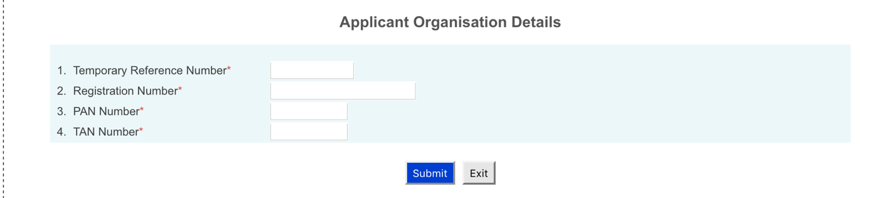

NOTE

1. Generate TP Code when the first section is saved and continued
2. When the user saves the first section, display message “Name of the Organization, PAN number, TIN Number and email id of the organization cannot be changed during registration process. Please verify again. Wish to verify again? <Yes/ No>, in case of No, proceed the next section else remain on the same page.
3. The TP Code should be sent by mail to the registered email address of the along with the registered Registration Number, PAN and TIN
4. User the TP Code, Registration Number, PAN and TIN for accessing the incomplete registration.
5. Do not create any user log-in till the time payment has been received.
6. When payment is submitted, create user log-in and default password and sent on the authorized person’s email id (not on organization’s email id or head’s email id.)